**BANK LOAN REPORT QUERY DOCUMENT**

**BANK LOAN REPORT | SUMMARY**

**KPI’s:**

**Total Loan Applications**

SELECT COUNT(id) AS Total_Applications FROM bank_loan_data



**MTD Loan Applications**

SELECT COUNT(id) as MTD_Total_Loan_aplications from bank_loan_data

WHERE MONTH(issue_date)= 12 AND YEAR (issue_date) =2021

**PMTD Loan Applications**

SELECT COUNT(id) as Total_Loan_aplications from bank_loan_data

WHERE MONTH(issue_date)= 11

**Total Funded Amount**

SELECT SUM(loan_amount) AS Total_Funded_Amount FROM bank_loan_data



**MTD Total Funded Amount**

SELECT SUM(loan_amount) AS MTD_Total_Funded_Amount FROM bank_loan_data

WHERE MONTH(issue_date) = 12

**PMTD Total Funded Amount**

SELECT SUM(loan_amount) AS PMTD_Total_Funded_Amount FROM bank_loan_data

WHERE MONTH(issue_date) = 11

**Total Amount Received**

SELECT SUM(total_payment) AS Total_Amount_Collected FROM bank_loan_data



**MTD Total Amount Received**

SELECT SUM(total_payment) AS Total_Amount_Collected FROM bank_loan_data

WHERE MONTH(issue_date) = 12



**PMTD Total Amount Received**

SELECT SUM(total_payment) AS Total_Amount_Collected FROM bank_loan_data

WHERE MONTH(issue_date) = 11



**Average Interest Rate**

SELECT AVG(int_rate) * 100 AS AVG_ADI FROM bank_loan_data



**MTD Average Interest**

SELECT ROUND(AVG(int_rate),4)*100 AS MTD_Avg_Int_Rate FROM bank_loan_data

WHERE MONTH(issue_date) = 12 AND YEAR(ISSUE_DATE) = 2021



**PMTD Average Interest**

SELECT ROUND(AVG(int_rate),4)*100 AS PMTD_Avg_Int_Rate FROM bank_loan_data

WHERE MONTH(issue_date) = 11 AND YEAR(ISSUE_DATE) = 2021

**Avg DTI**

SELECT ROUND(AVG(DTI),4)*100 AS AVG_DTI FROM bank_loan_data

**MTD Avg DTI**

SELECT ROUND(AVG(DTI),4)*100 AS MTD_AVG_DTI FROM bank_loan_data

where month(issue_date) = 12 and year(issue_date) = 2021



**PMTD Avg DTI**

SELECT ROUND(AVG(DTI),4)*100 AS PMTD_AVG_DTI FROM bank_loan_data

where month(issue_date) = 11 and year(issue_date) = 2021

**GOOD LOAN ISSUED**

**Good Loan Percentage**

SELECT

(COUNT(CASE WHEN LOAN_STATUS = 'Fully paid' or LOAN_STATUS = 'CURRENT' THEN ID END) * 100.0)

/

COUNT(ID) AS Good_loan_percentage

from bank_loan_data



**Good Loan Applications**

select count(id) as Good_loan_applications from bank_loan_data

where loan_status = 'fully paid' or loan_status = 'current'



**Good Loan Funded Amount**

select sum(Loan_amount) as Good_Loan_Funded_Amount from bank_loan_data

where loan_status = 'fully paid' or loan_status = 'current'



**Good Loan Amount Received**

select sum(total_payment) as Good_Loan_Amount_Received from bank_loan_data

where loan_status = 'fully paid' or loan_status = 'current'

**BAD LOAN ISSUED**

**Bad Loan Percentage**

SELECT

(COUNT(CASE WHEN loan_status = 'Charged Off' THEN id END) * 100.0) /

COUNT(i

d) AS Bad_Loan_Percentage

FROM bank_loan_data



**Bad Loan Applications**

select count(id) as bad_loan_application from bank_loan_data

where loan_status='charged off'

**Bad Loan Funded Amount**

select sum(loan_amount) as bad_loan_funded_amount from bank_loan_data

where loan_status='charged off'



**Bad Loan Amount Received**

SELECT SUM(total_payment) AS Bad_Loan_amount_received FROM bank_loan_data

WHERE loan_status = 'Charged Off'



**LOAN STATUS**

SELECT

loan_status,

COUNT(id) AS total_loan_applications,

SUM(total_payment) AS Total_Amount_Received,

SUM(loan_amount) AS Total_Funded_Amount,

AVG(int_rate * 100) AS Interest_Rate,

AVG(dti * 100) AS DTI

FROM

bank_loan_data

GROUP BY

loan_status

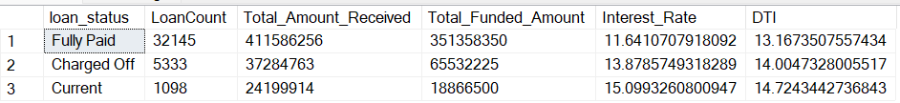

SELECT

loan_status,

SUM(total_payment) AS MTD_Total_Amount_Received,

SUM(loan_amount) AS MTD_Total_Funded_Amount

FROM bank_loan_data

WHERE MONTH(issue_date) = 12

GROUP BY loan_status

**BANK LOAN REPORT | OVERVIEW**

**MONTH**

SELECT

MONTH(issue_date) AS Month_Nunber,

DATENAME(MONTH, issue_date) AS Month_name,

COUNT(id) AS Total_Loan_Applications,

SUM(loan_amount) AS Total_Funded_Amount,

SUM(total_payment) AS Total_Amount_Received

FROM bank_loan_data

GROUP BY MONTH(issue_date), DATENAME(MONTH, issue_date)

ORDER BY MONTH(issue_date)

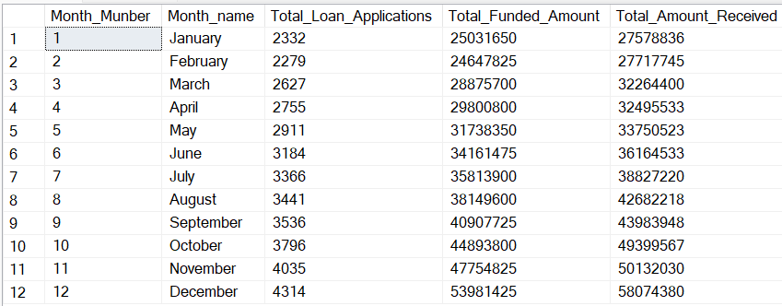

SELECT

address_state AS State,

COUNT(id) AS Total_Loan_Applications,

SUM(loan_amount) AS Total_Funded_Amount,

SUM(total_payment) AS Total_Amount_Received

FROM bank_loan_data

GROUP BY address_state

ORDER BY COUNT(id) desc

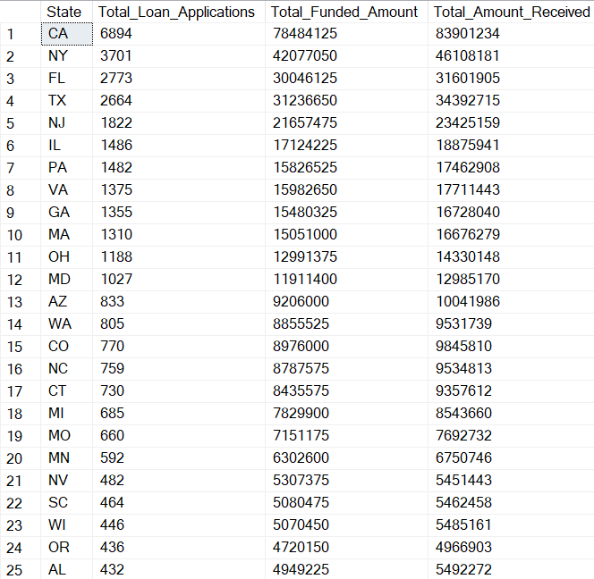

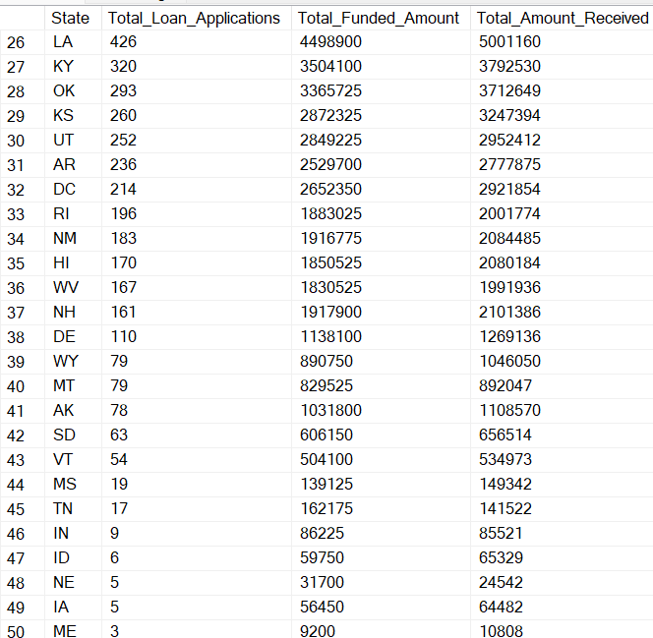

**TERM**

SELECT

term AS Term,

COUNT(id) AS Total_Loan_Applications,

SUM(loan_amount) AS Total_Funded_Amount,

SUM(total_payment) AS Total_Amount_Received

FROM bank_loan_data

GROUP BY term

ORDER BY term

**EMPLOYEE LENGTH**

SELECT

emp_length AS Employee_Length,

COUNT(id) AS Total_Loan_Applications,

SUM(loan_amount) AS Total_Funded_Amount,

SUM(total_payment) AS Total_Amount_Received

FROM bank_loan_data

GROUP BY emp_length

ORDER BY count(id) desc

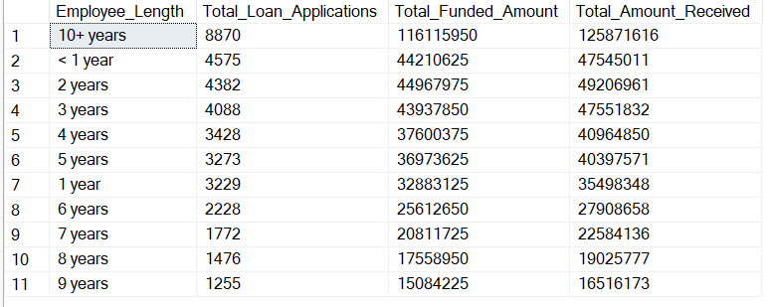

**PURPOSE**

SELECT

purpose AS PURPOSE,

COUNT(id) AS Total_Loan_Applications,

SUM(loan_amount) AS Total_Funded_Amount,

SUM(total_payment) AS Total_Amount_Received

FROM bank_loan_data

GROUP BY purpose

ORDER BY count(id) desc

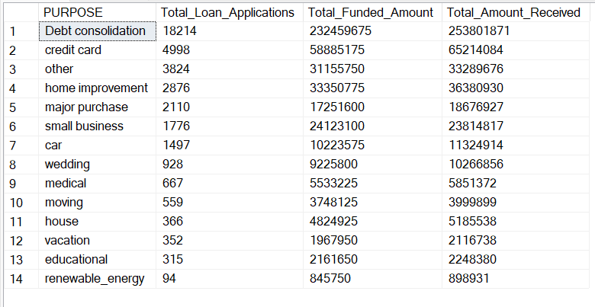

**HOME OWNERSHIP**

SELECT

home_ownership AS Home_Ownership,

COUNT(id) AS Total_Loan_Applications,

SUM(loan_amount) AS Total_Funded_Amount,

SUM(total_payment) AS Total_Amount_Received

FROM bank_loan_data

GROUP BY home_ownership

ORDER BY count(id) desc

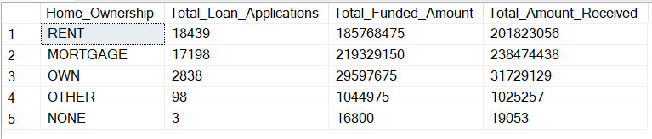

SELECT

home_ownership AS Home_Ownership,

COUNT(id) AS Total_Loan_Applications,

SUM(loan_amount) AS Total_Funded_Amount,

SUM(total_payment) AS Total_Amount_Received

FROM bank_loan_data

where grade = 'a' and address_state = 'ca'

GROUP BY home_ownership

ORDER BY count(id) desc

